GhostHouses - Stage A Submission
Course: 2340311 Yearly Project (Stage A).
Repository: GhostHouses.

1. User Stories (Changes vs HLD, Implemented, Remaining)
The HLD user stories are still used as the main scope, but client feedback led to many UI/UX refinements and reporting changes (filters, logs layout, sorting, export format). These changes are reflected in closed issues.
User Story | Description | Tracked Issue | Status (Issue State)
US-1 | Role model (Viewer, User–Editor, Admin). | #20 As an admin, I want a clear role model (Viewer, User–Editor, Admin) so that access and responsibilities are unambiguous. | open
US-2 | 2FA login for authorized access. | #21 As an admin, I want users to log in with 2FA so that only authorized people can use the system. | open
US-3 | User permissions (view/edit/no access). | #22 As an admin, I want to set municipality user permissions to view/edit/can’t access so that system access is controlled. | open
US-4 | View building details. | #23 As a viewer, I want to view building details so that I can review its current status. | open
US-5 | Search and filter buildings. | #24 As a viewer, I want to search and filter buildings (street, house no., nickname, status/category, area) so that I can quickly find relevant records. | open
US-6 | Open building card with photos. | #25 As a viewer, I want to open a building page/card with photos so that I can understand the property at a glance. | open
US-7 | Export building card image. | #26 As a viewer, I want to produce a building card image to include in presentations. | open
US-8 | Add new buildings. | #27 As an editor, I want to add new buildings so that the database stays current. | open
US-9 | Update existing buildings. | #28 As an editor, I want to update existing buildings so that errors and changes are reflected promptly. | open
US-10 | Remove buildings with safeguards. | #29 As an editor, I want to remove buildings (with safeguards) so that obsolete or duplicate entries are cleaned up. | open
US-11 | View building change log. | #30 As a viewer, I want to view a building’s change log so that I can understand its history. | open
US-12 | Search and filter logs. | #31 As a viewer, I want to search and filter logs so that I can locate specific events quickly. | open
US-13 | Add/edit log entries. | #32 As an editor, I want to add or edit log entries for a building so that important actions are recorded. | open
US-14 | Delete log entries (admin). | #33 As an admin, I want to delete log entries so that sensitive or erroneous logs can be corrected while preserving accountability. | open
US-15 | Full audit trail (who/what/when). | #34 As a viewer, I want a full audit trail of who changed what and when so that compliance requirements are met. | open
US-16 | Sync data with external municipal systems. | #35 As an editor, I want status/data to sync with external municipality systems so that data remains consistent across systems. | open
- Implemented in Stage A (high-level):
- Buildings list, filters, add/edit/delete flows, and detailed building view.
- Logs view with filtering, snapshots, and audit visibility.
- Users & roles UI, login + OTP page.
- Streets management page and export features.
- Remaining for next semester (based on open issues):
- External systems sync (US-16), log edit/delete (US-13/14), full audit trail (US-15).
- Building card export + images support (US-6/7), duplicate prevention flow.
- OTP integration with real provider and deployment to client servers.

2. Design (Class Diagram)
Class diagram below reflects the implemented domain model (green) and planned components (yellow). Planned components include BuildingImage and BuildingCardExporter.
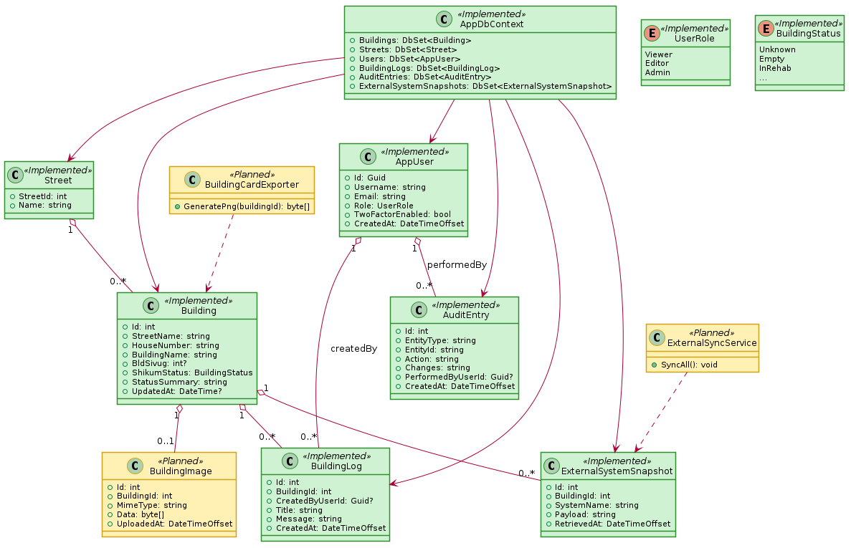

3. GitHub Repository Readiness
Structure overview:
- `project/web-server` contains backend (ASP.NET) and frontend (React).
- `project/db-server` and `project/docker-compose.yml` provide local/dev environment.
- `docs/` stores requirements and submission artifacts.
- Branching uses `dev` plus issue-specific branches (Issues/#NN-...).

4. CI/CD (Current vs Planned)
Planned (HLD): CI on PR/merge to dev (lint/tests), CD to staging after merge, production deploy after QA approval with rollback.
Current: manual Docker Compose deployment on a host PC with port forwarding; HTTPS not fully managed. Next step: move to client infrastructure and automate CI/CD.

5. POC Status
HLD POC: Excel import into the system database. Status: implemented and used for initial data ingestion; verify with the latest import flow.

6. Current Project Risk
Primary risk: deployment reliability and dependency on external municipal APIs/SSO. Mitigation: move hosting to client servers, formalize API contracts, add monitoring and backups.

7. Risk Management Table
Risk Severity | Likelihood | Mitigation | Severity After Mitigation | Likelihood After Mitigation
High | Medium | Move hosting to managed client servers; add backups and monitoring. | Medium | Low
High | Medium | Define API contracts early; build mock/stub integration layer. | Medium | Low
Medium | Medium | Add DB indexes, pagination, and load testing for filters/logs. | Low | Low
High | Low | Enforce RBAC and audit logs for sensitive operations. | Medium | Low
Medium | Medium | Add validation for duplicates and data quality checks. | Low | Low

8. Current Backlog (Open Issues)
- #74 building card multiselect
- #36 Add proper .gitignore
- #35 As an editor, I want status/data to sync with external municipality systems so that data remains consistent across systems.
- #34 As a viewer, I want a full audit trail of who changed what and when so that compliance requirements are met.
- #33 As an admin, I want to delete log entries so that sensitive or erroneous logs can be corrected while preserving accountability.
- #32 As an editor, I want to add or edit log entries for a building so that important actions are recorded.
- #31 As a viewer, I want to search and filter logs so that I can locate specific events quickly.
- #30 As a viewer, I want to view a building’s change log so that I can understand its history.
- #29 As an editor, I want to remove buildings (with safeguards) so that obsolete or duplicate entries are cleaned up.
- #28 As an editor, I want to update existing buildings so that errors and changes are reflected promptly.
- #27 As an editor, I want to add new buildings so that the database stays current.
- #26 As a viewer, I want to produce a building card image to include in presentations.
- #25 As a viewer, I want to open a building page/card with photos so that I can understand the property at a glance.
- #24 As a viewer, I want to search and filter buildings (street, house no., nickname, status/category, area) so that I can quickly find relevant records.
- #23 As a viewer, I want to view building details so that I can review its current status.
- #22 As an admin, I want to set municipality user permissions to view/edit/can’t access so that system access is controlled.
- #21 As an admin, I want users to log in with 2FA so that only authorized people can use the system.
- #20 As an admin, I want a clear role model (Viewer, User–Editor, Admin) so that access and responsibilities are unambiguous.
- #19 Make a convention document
- #9 duplicate buildings protection
- #8 add images feaure for building's details
- #7 add a feature to export building's details as a png file (building card)
- #5 fetch data from other data bases
- #4 setup a real OTP

9. UML Diagrams (Required)

Use Case (Implemented / Planned / Backlog)
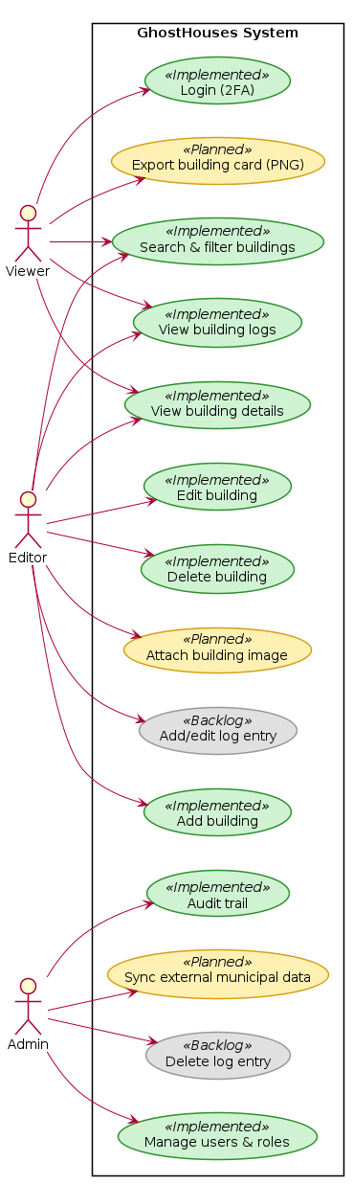

Class Diagram


Deployment - Desired
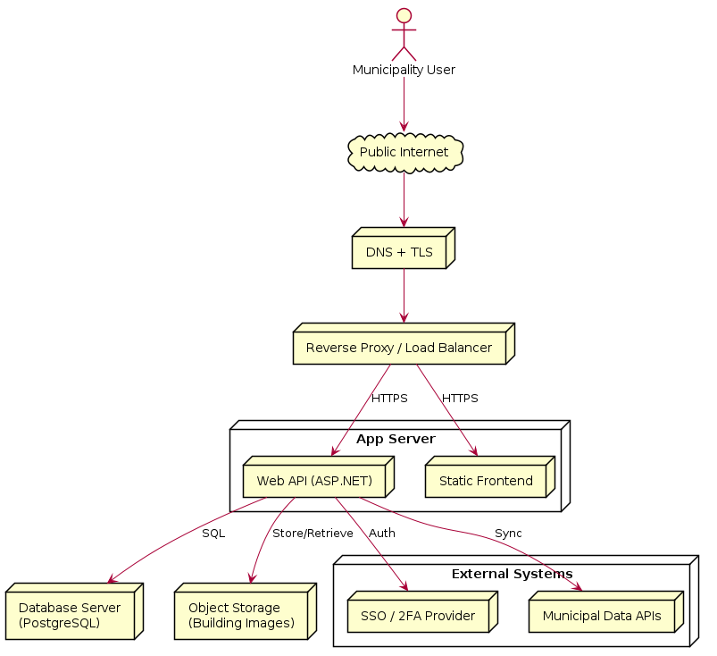

Deployment - Current
